**Train Controller (Hardware) - Installation Manual**

**Chad Collina**

### **Part I: Install Libraries**

1. Ensure that PyQt5 is installed on the machine: “pip install pyqt5”
2. Install pySerial on the device: “pip install pyserial”

### **Part II: Enable Serial Communication**

1. Configure the USB-to-Serial adapter on the Raspberry Pi 4 pins as follows:
   1. White = GPIO 14 (TXD)
   2. Green = GPIO 15 (RXD)
   3. Black = Ground

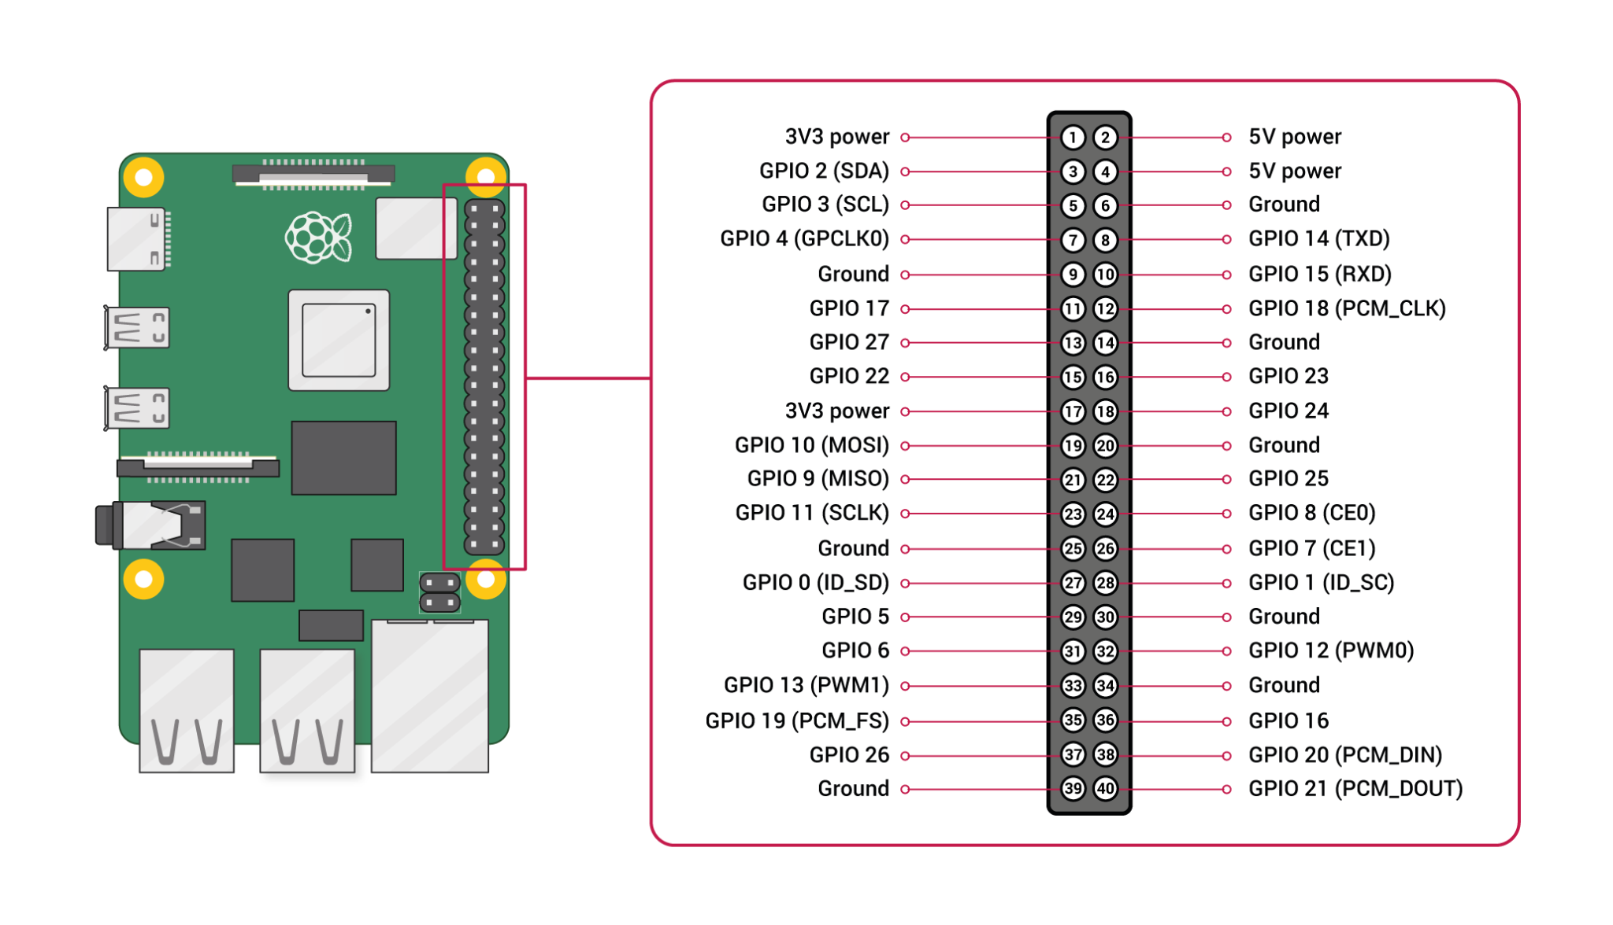

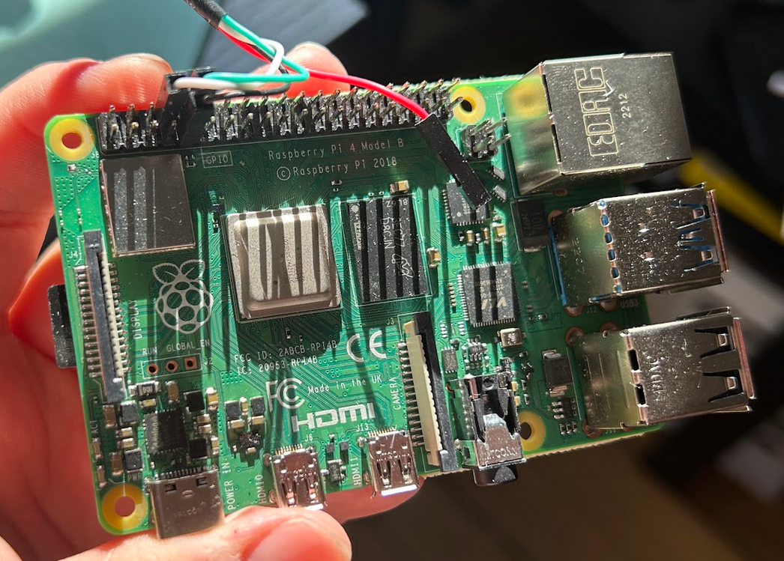

1. Plug the other end of the adapter into the USB port on the computer.
2. Follow instructions to install appropriate drivers for the hardware: <https://learn.adafruit.com/adafruits-raspberry-pi-lesson-5-using-a-console-cable/software-installation-windows>
3. Check “Device Manager” on the machine to determine which COM port corresponds to hardware. Change this accordingly within the code.

### **Part III: Remote-Into Raspberry Pi 4**

1. Install VNC Viewer to view PLC File Upload UI: <https://www.realvnc.com/en/connect/download/viewer/>
2. Run the file Power.py file